UNIT 1 : BACK TO SCHOOL
A4-5 (Page 12-13 )
I. Vocabulary
1. Lunchroom ['lʌntʃru:m] (n): phòng ăn trưa
2. Just fine [dɜʌstfɑɪn] (adj): rất khỏe
= very well
- Pretty ['prɪtɪ] (adv): khá, hơi
- =>Pretty good ['prɪtɪ gʊd] (adj): khá khỏe/tốt
5. So am I = Me , too . : Tôi cũng vậy.
Ex : You are in class 7A . So am I / Me , too.
II. Practice
1. Listen . Complete these dialogues .( SGK, p12)
a) Mr.Tan: Hello, Lien. ……………………?
Miss Lien: ………………, thank you…………………….., Tan?
Mr. Tan: ……………………., but I’m very busy.
Miss Lien:……………….
b) Nam: Good afternoon, Nga. ……………………..?
Nga: …………., thanks. ………………….., Nam?
Nam: ……………….., thanks.
Nga: I’m going to the lunch room.
Nam: Yes. ………………
2. Listen. Write the letters of the dialogues in the order you hear.(SGK. P13)

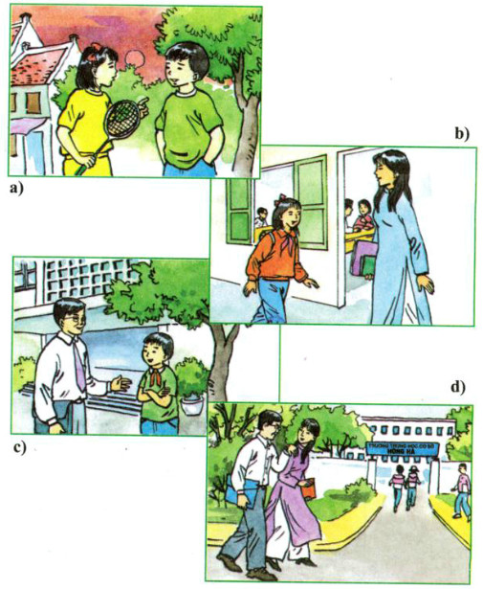

Answer :1………….. 2-…………… 3- …………… 4-………………
III. Exercise
1. Arrange the following sentences in right dialogues.
a.Hello, Nga. Nice to see you again.
b.Nice to meet you, Minh.
c.Hello, Phong.
d. Nice to see you. How are you?
e. Fine, thank. This s our new classmat. His name is Minh.
f. Nice to meetyou, too.
Answer : 1……… ,2……… ,3……… ,4………. ,5…… , 6………
2.Arrange the words in the correct order
1. is/ your/ how/ school/ to/ it/ far/ your/ from/ house?
2. your/ classmate/ where/ live/ does?
3. have/ any/ doesn't/ in/ she/ friends/ Ha Noi
4. new/ has/ a/ students/ of/ her/ school/ lot.
5. with/ her/ lives/ Hoa/ in/ uncle/ aunt Ha Noi/ and.
IV.Homework :
- Learn by heart the newwords .
- Prepare new lesson B1,2 ( p 15-16 )

